**ITIS 4250 / 5250**

**Computer Forensics**

**Hamsini Battula**

**Semester Project**

**Overview:**

Dr. Quincy has requested take on Detective Fletcher's final case, which involves conducting a forensic analysis of a KAPE extraction of Gene Poole's newest desktop. Gene Poole is suspected of involvement in a range of criminal activities, including the manufacturing and selling of drugs, chemical and biological weapons, and ecoterrorism. Detective Fletcher's warrant covers all criminal activity, and I will be examining a forensic image of Gene Poole's computer to uncover any evidence related to the case.

**Forensic Acquisition and Exam Preparation :**

By importing the image GP2022.E01, Verified the results.

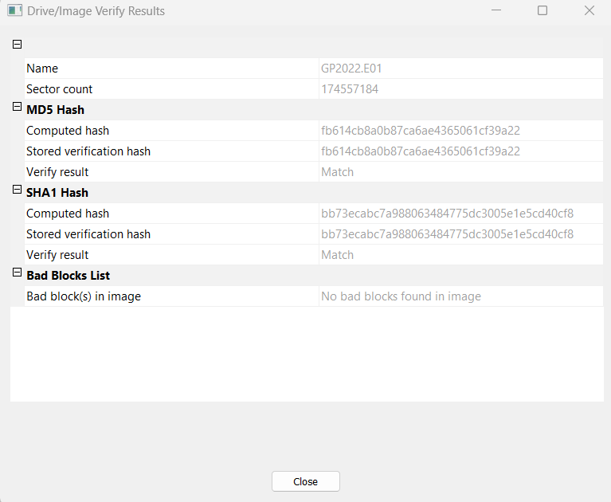

***Hash Value:*** fb614cb8a0b87ca6ae4365061cf39a22

**Softwares used:**

1. AccessData Ftk Imager 4.7.1.2
2. Arsenal Image Mounter
3. Autopsy 4.20.0
4. Access Data Registry Viewer
5. KAPE
6. Win Prefetch Viewer x64
7. Windows 10 Operating System HP envy 16.0 GB RAM, 64-bit operating system, x64-based processor

I used Arsenal Image Mounter to mount the E01 file and made it writeable temporarily.

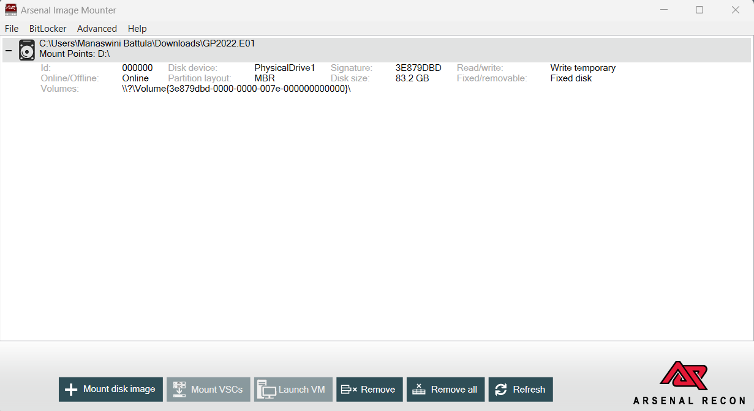

I obtained the files in D\: drive after mounting in AIM.

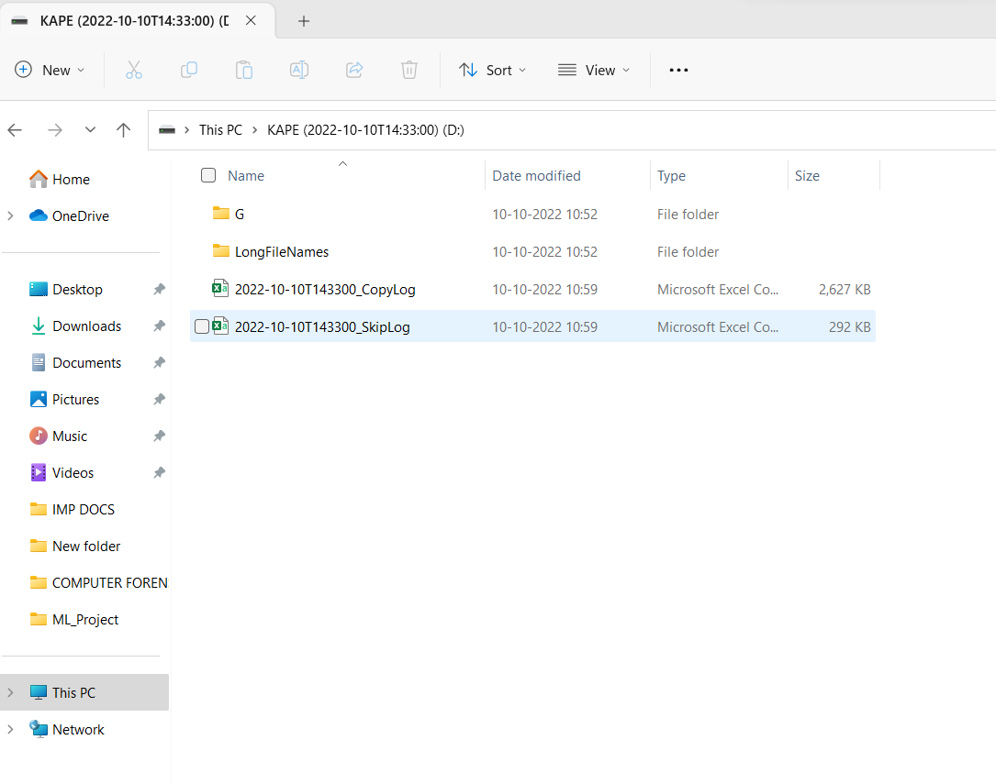

I navigated to G file to copy the file location.

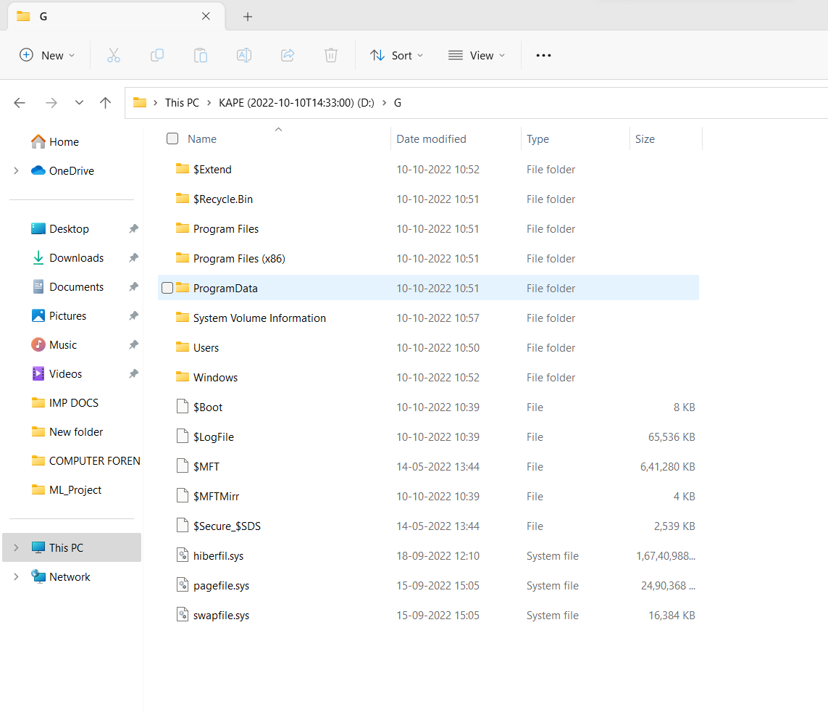

**Forensic Analysis:**

I created a new case as “SemProject” to analyze the files in Autopsy.

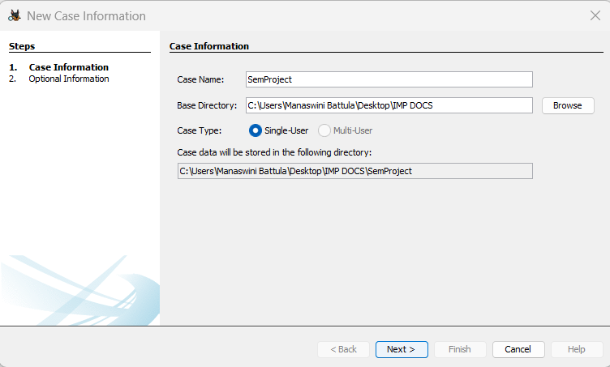

In Autopsy, I added the drive location as a data source in logical files to analyze the data.

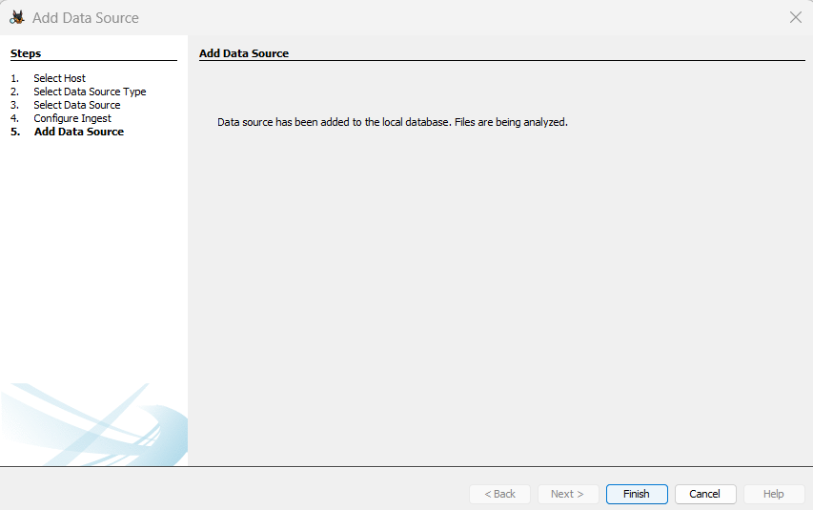

We can view the data sources in the below figure:

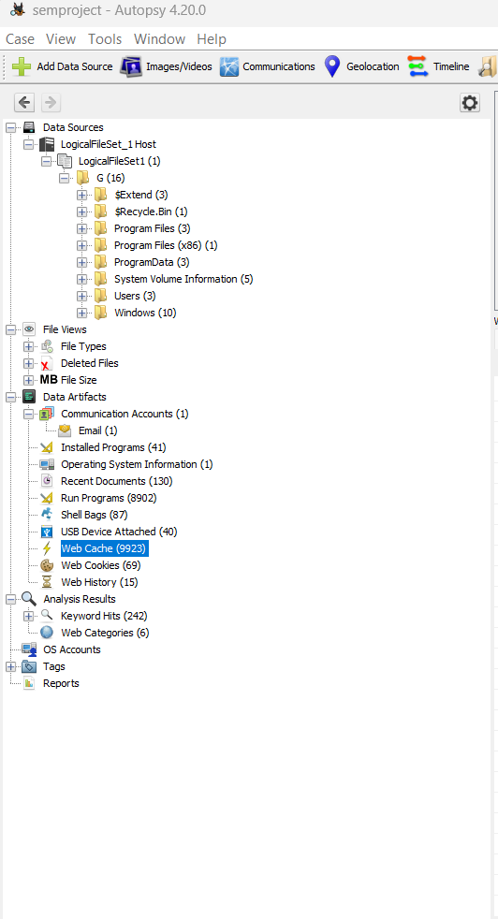

1. Gene denies the computer is his. What was the name of the computer?

By Navigating to Data Artifacts -> Operating system Information -> Name of the computer can be found.

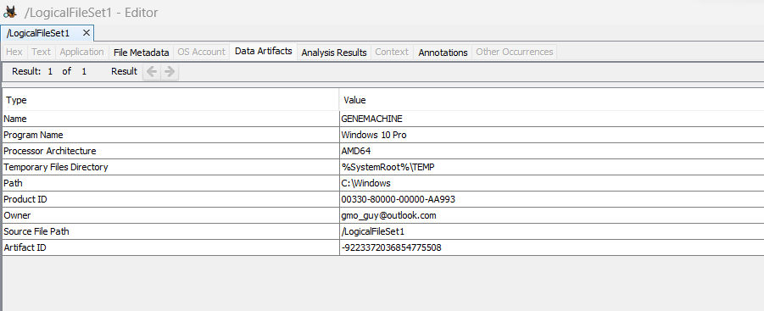

*Figure*: Contains name of the computer

Also, The registered owner information can be found by navigating through Root -> Windows NT -> CurrentVersion:

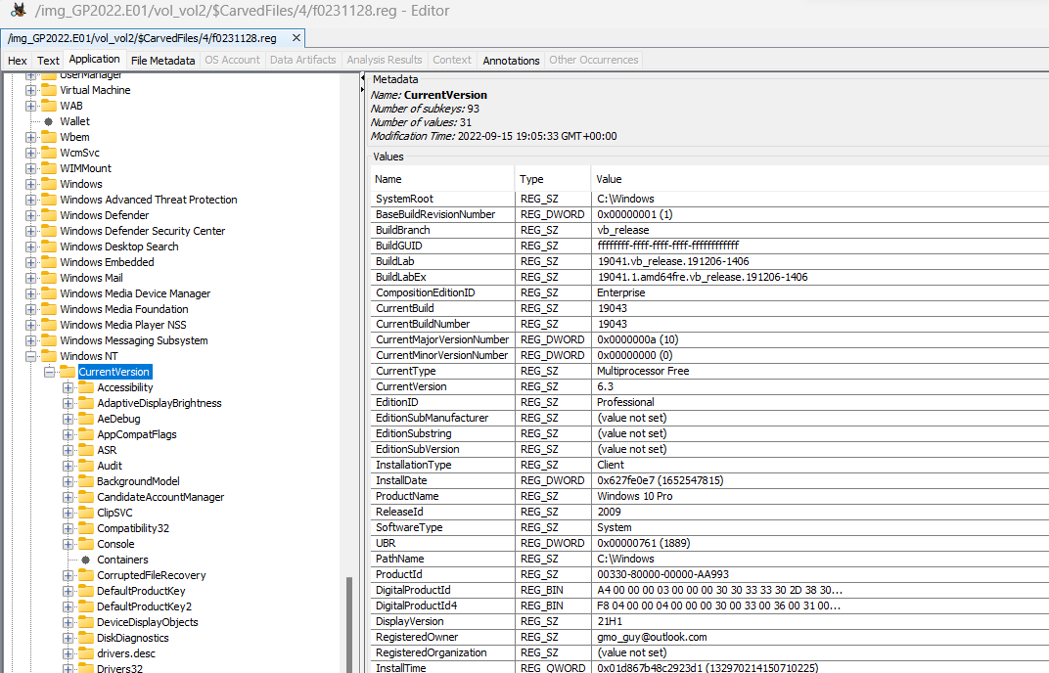

1. Rett Harring admitted during an interview with Bladen County Sheriff’s Department Detectives that he picked up a pill press on a trip for Gene down to Dublin, NC, but denied delivering several crates of genetically modified peanuts to Houston’s Peanuts in Dublin. The diligent workers as Houston’s thought something was weird about the delivery and called the Sheriff’s Department. Is there any evidence Gene knew Rett would travel to Dublin from his home in Salemburg, NC?

By navigating to File Views -> File Types -> By Extension -> Documents -> PDF, obtained the **RettGetPress.pdf** file which contains the travel information.

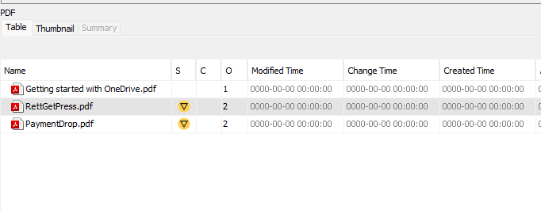

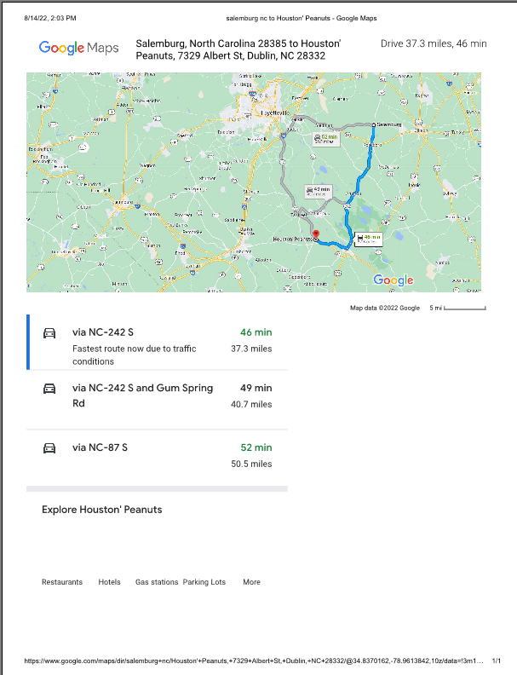

By verifying the history of google maps found the location as: https://www.google.com/maps/place/Houston'+Peanuts/@34.6571139,-78.7268822,17z/data=!4m6!3m5!1s0x89aafe5d5ac62427:0x19245f25838683bd!8m2!3d34.6571139!4d-78.7243073!16s%2Fg%2F11cjgb45bb

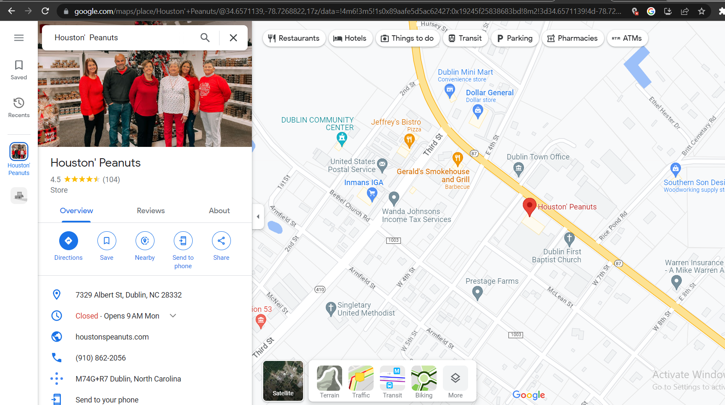

*Figure*: Location on google maps

1. The employees at Houston’s told Sheriff’s Deputies that Rett arrived in an old red truck. Rett asked for a lawyer prior to detectives asking him about his vehicle in use that day. Can you find any evidence on Gene’s computer about the truck Rett might have used? We know the two were in frequent communication and have an informant who said Rett likes to brag to Gene about any crimes he commits or is thinking about.

By navigating to Data Artifacts -> EXIF metadata We can find the Images of the vehicle.

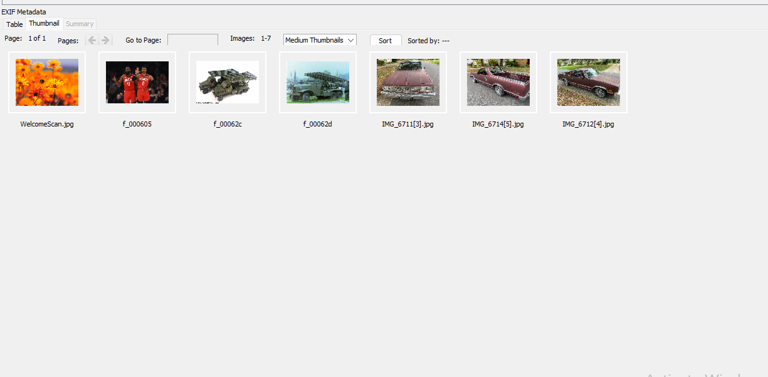

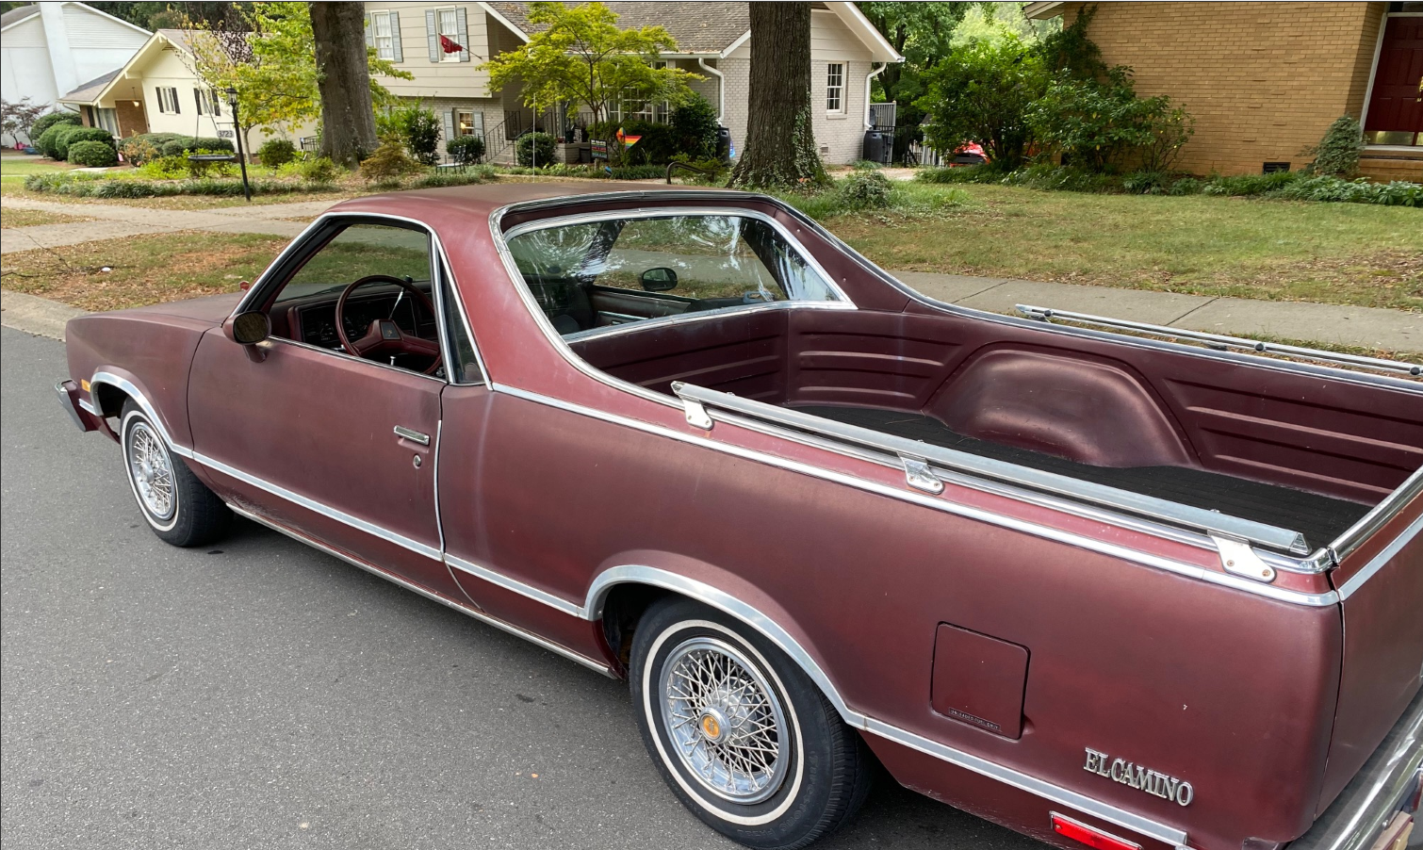

*Figure:* The clear view of the vehicle

1. The truck may have been stolen as Rett often steals vehicles for use in his criminal activity. If you found a possible match, can you determine where the vehicle may have come from?

By clicking on the GeoLocation feature in the EXIF files. The place is tracked from which it was stolen is Sulkirk Road in Charlotte, North Carolina.

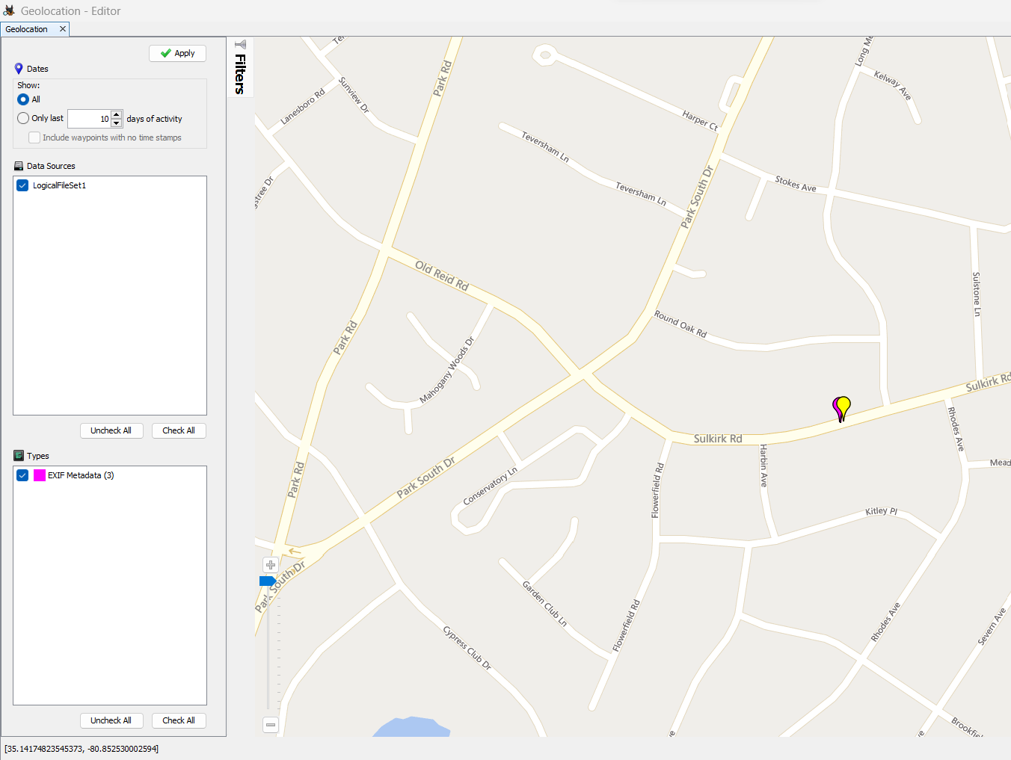

*Figure*: Image of the map which shows the location near sulkirk Rd

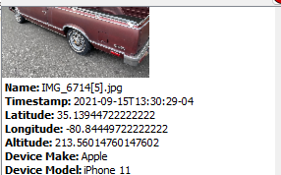

*Figure:* It contains accurate location.

1. Are there any photos of military rockets on his computer apart from web browser cache? If so, where. If not, where might they have been saved?

By navigating to **LogicalSet1 -> G -> Users -> gmo_g -> Downloads,** we can find the images of military rockets.

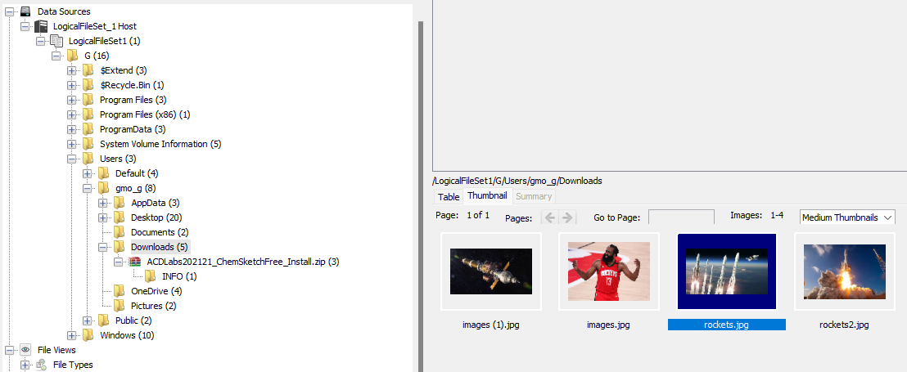







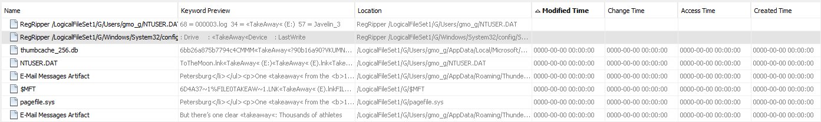

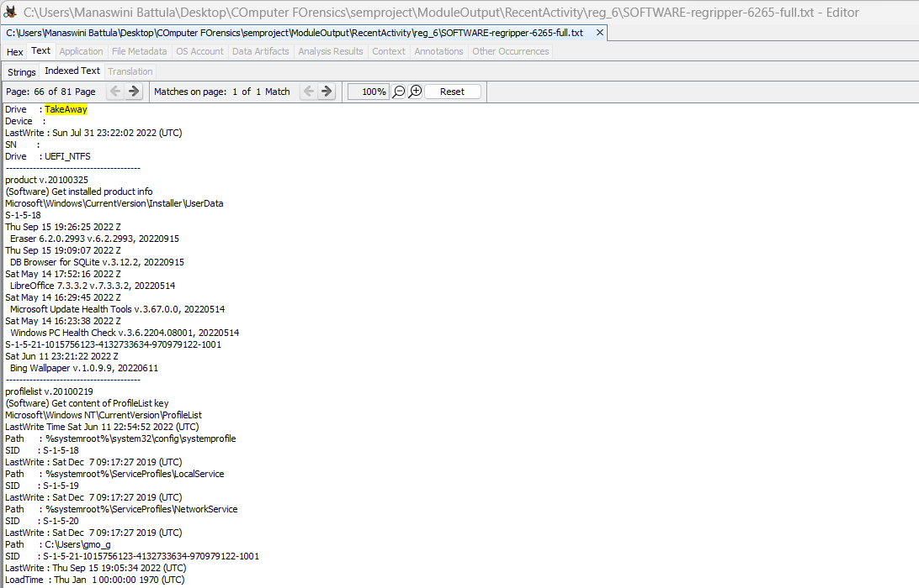

Figure: Drive with TakeAway(E).ink

1. Has Gene discussed malware with anyone?

By Navigating to email communications in Data Artifacts we can find the Email contains the subject MO-NAY contains the email communication between [rett.harring@outlook.com](mailto:rett.harring@outlook.com) and [gmo_guy@outlook.com](mailto:gmo_guy@outlook.com) which provides evidence of the discussion.

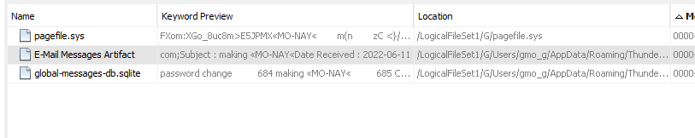

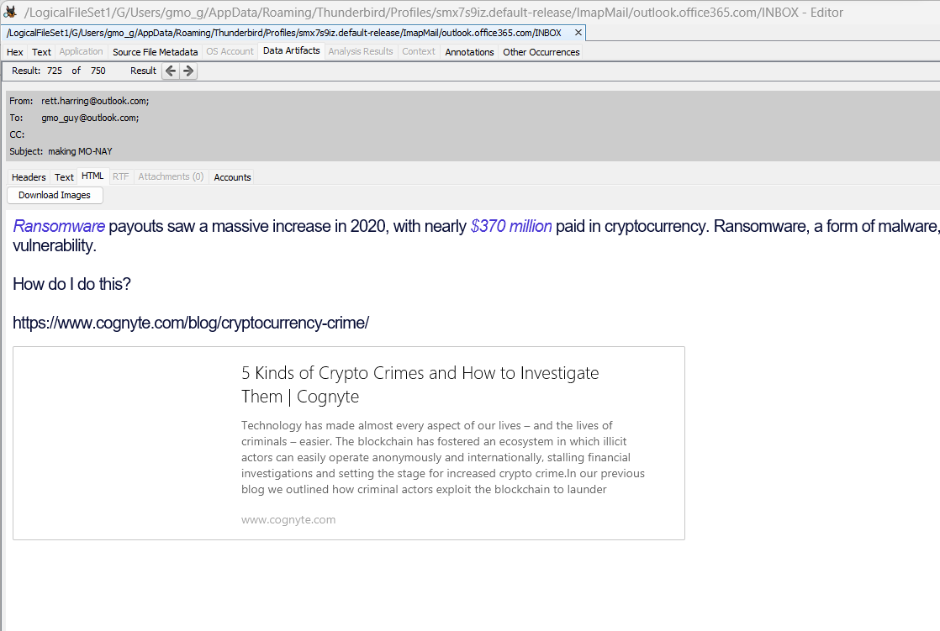

*Figure:* Email Communication

1. Are there any hidden lists of chemicals you can find? Gene is known to hide his shopping lists after his first bust.

Navigating to Data Sources -> LogicalFileSet_1 Host -> LogicalFileSet1->G->Users- >gmo_g->Documents->PoetryInMotion.doc we can find the list of chemical written in poem. And in excel sheet of Cursor.xls

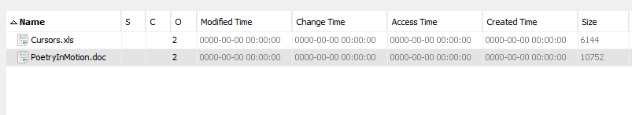

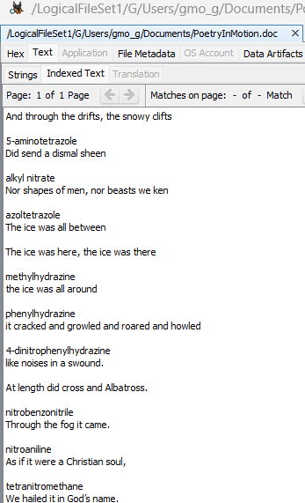

*Figure:* PoetryInMotion.doc

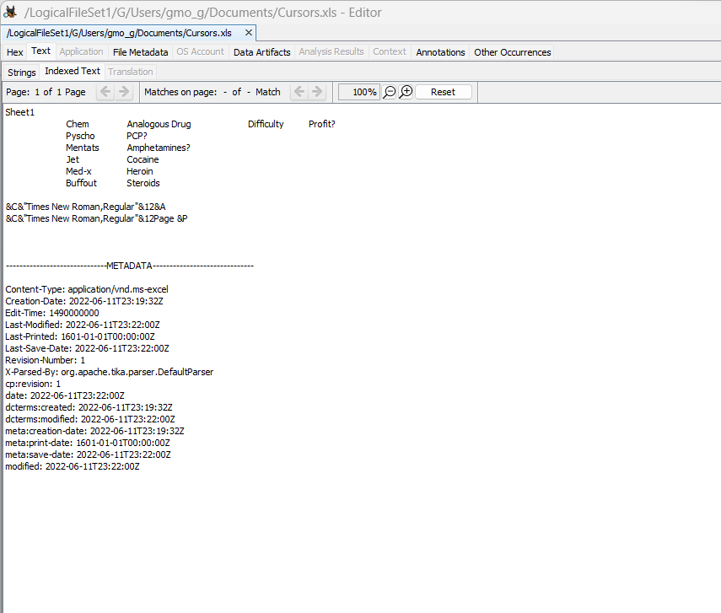

*Figure:* Contains chemicals in Cursors.xls



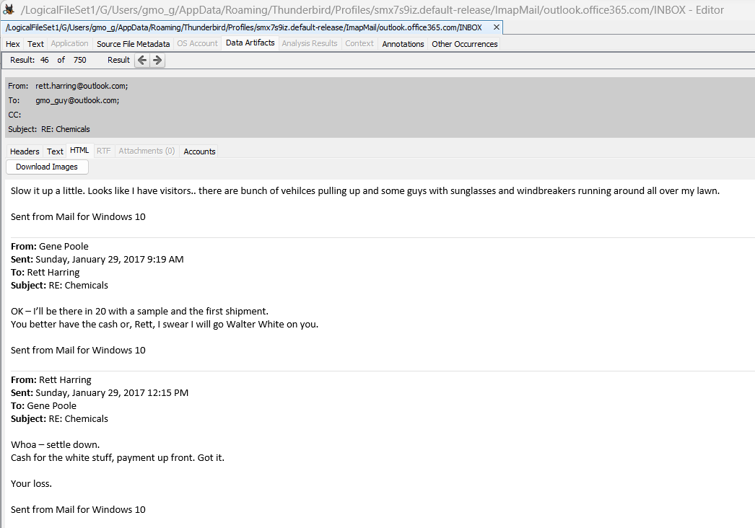

*Figure:* email communication between rett harring and gene poole regarding chemicals.

1. Where was Gene going to drop the payment to Rett?

Navigate to File View -> File Types -> Documents -> PDF -> PaymentDrop.pdf to find the payment location which is Pinehurst, North Carolina.

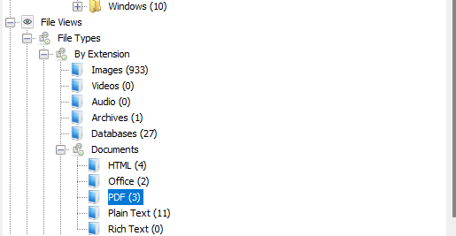

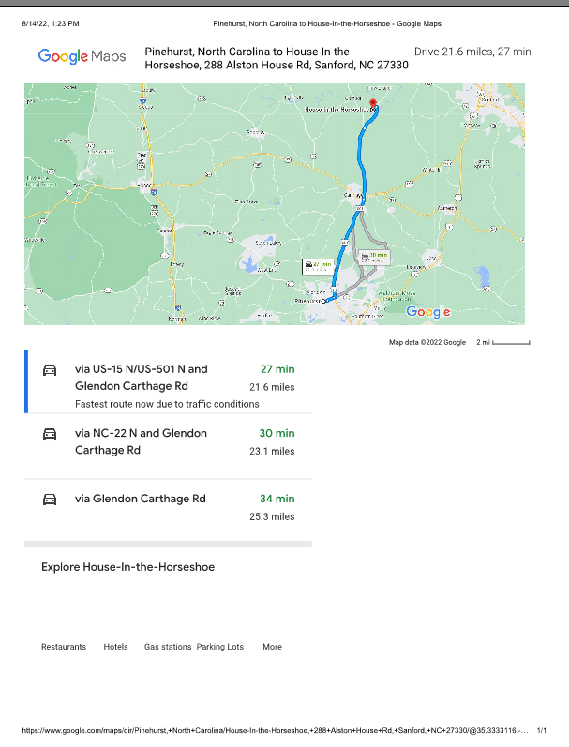

*Figure:* Payment Location of Rett.

1. Gene denies obstructing justice. Does he have any anti-forensics tools installed?

To find the anti-forensics tools we can navigate to Data Artifacts -> Installed Programs we can find the software Eraser.

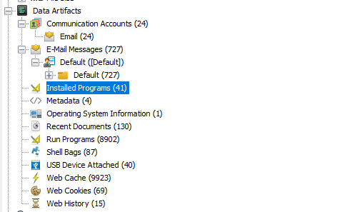

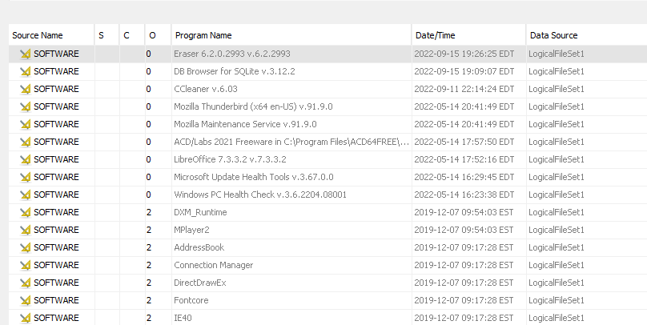

*Figure:* Eraser (anti forensic tools)

1. Has Gene run any anti-forensics programs?

Under the Data Artifacts section, specifically the Run Programs subsection, it can be observed that Eraser.exe application was executed repeatedly .

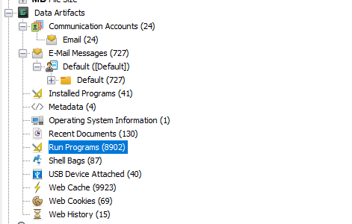

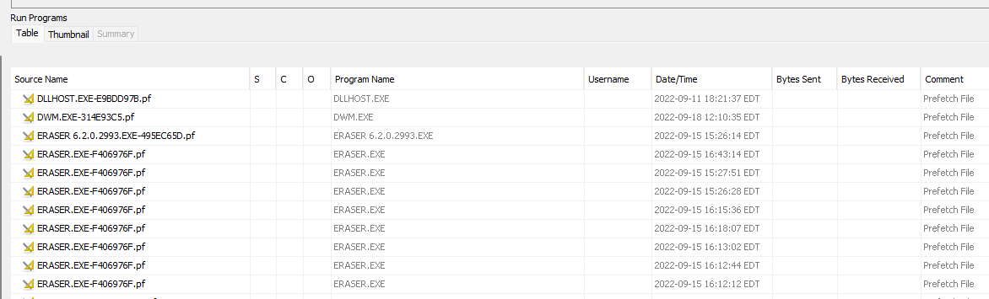

*Figure:* Eraser was run multiple times.

1. Has Gene instructed anyone else how to do this?

By navigating to Email Messages in Data Artifacts with the subject Reply to get rid of internet junk which contains the body instructing to get rid of the evidences.

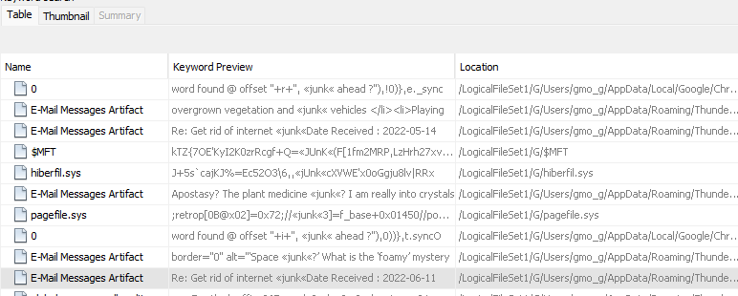

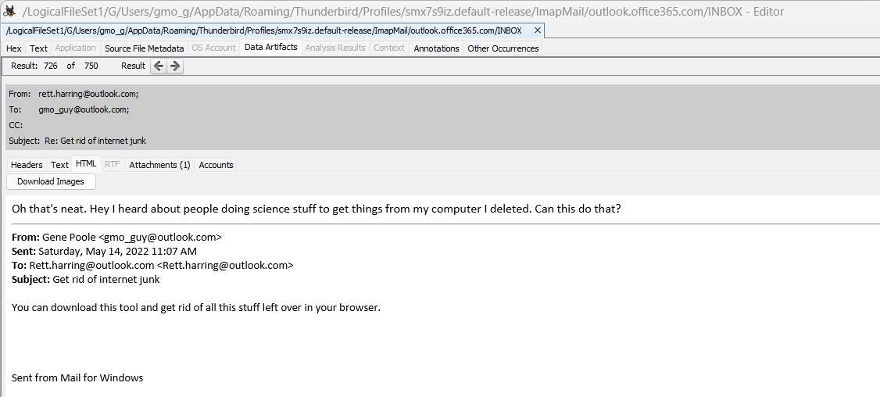

*Figure:* Email Communication.

1. Gene denies having used specific chemicals obtained from Dow, but admits he may have

casually browsed their website. Is there anything more than browser history to suggest he might have saved information from Dow or intended to revisit their site later?

Email contains the subject stating that Dow Chemical Closing Charlotte Plant.

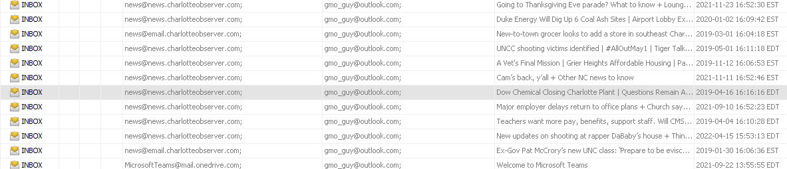

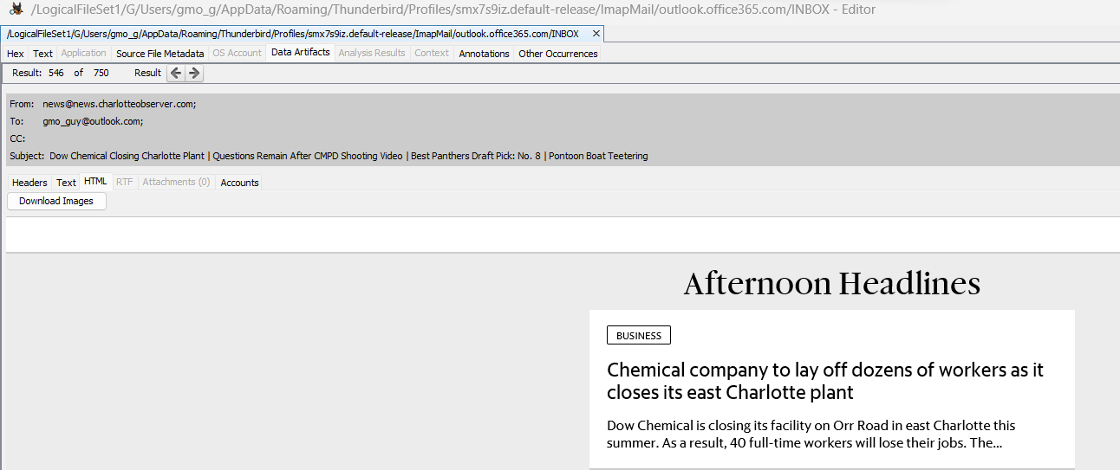

Also the bookmarks “Bookmarks” and “Bookmarks.bak” with name “chems” states that he saved information related to Dow for specific chemicals which indicates he might have saved it to revisit later.

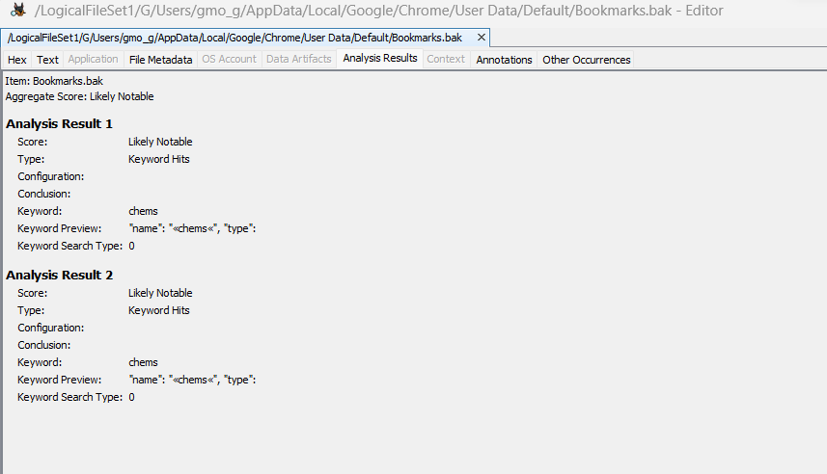

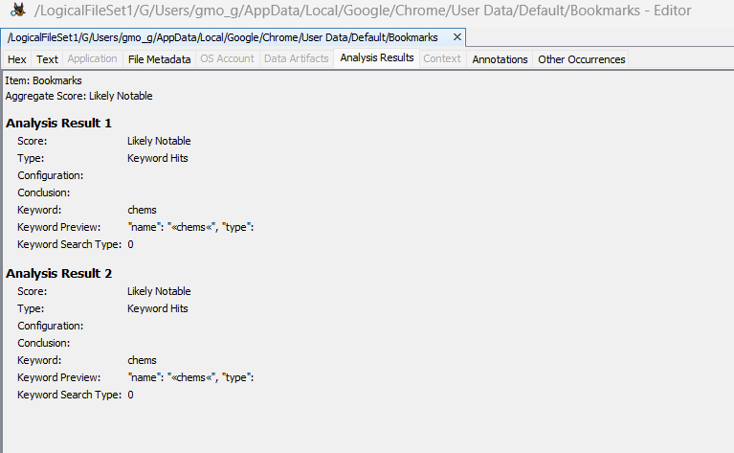

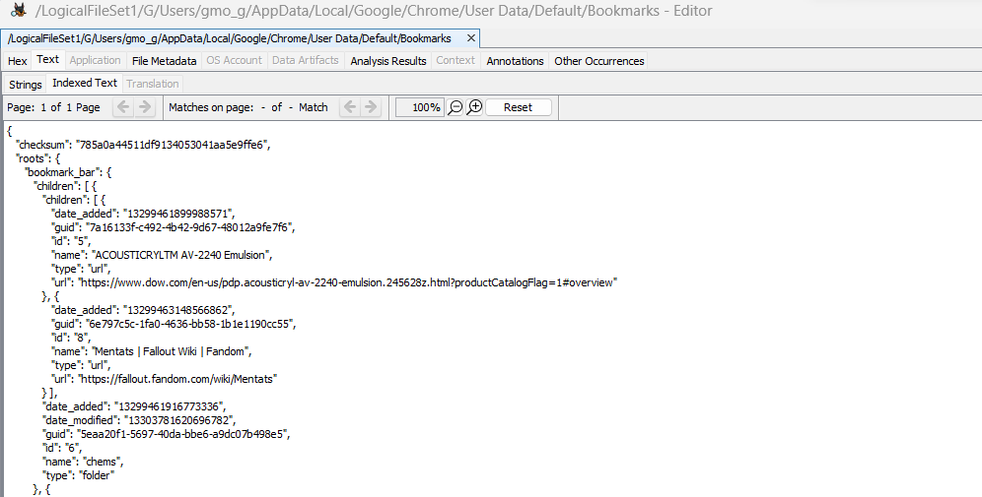

*Figure:* The link to open dow website

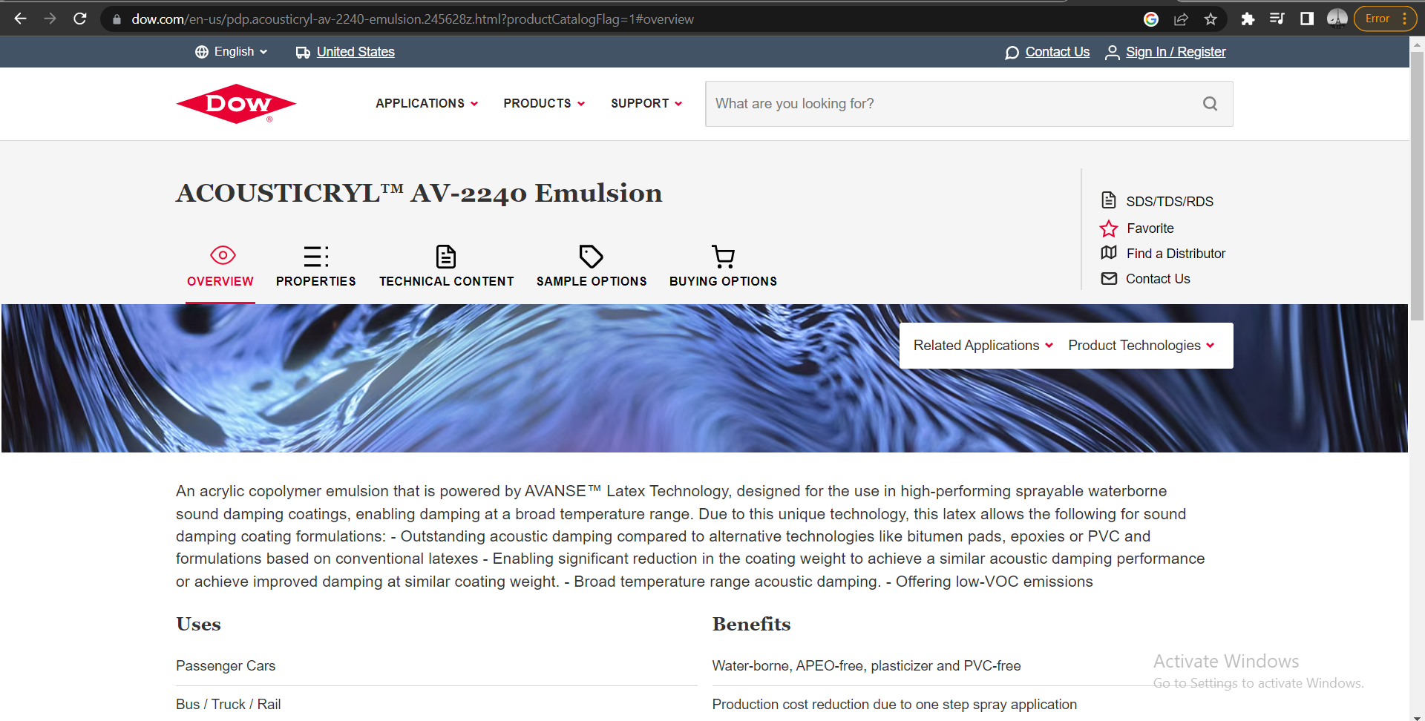

*Figure:* Dow Website

1. How many external storage devices were connected to the computer?

By navigating to Data Artifacts -> USB Device Attached we can see 40 external storage devices are connected.

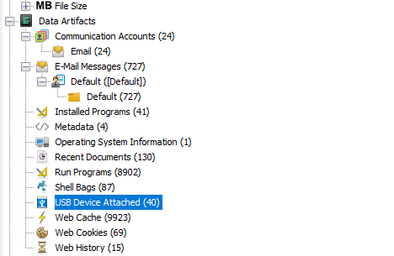

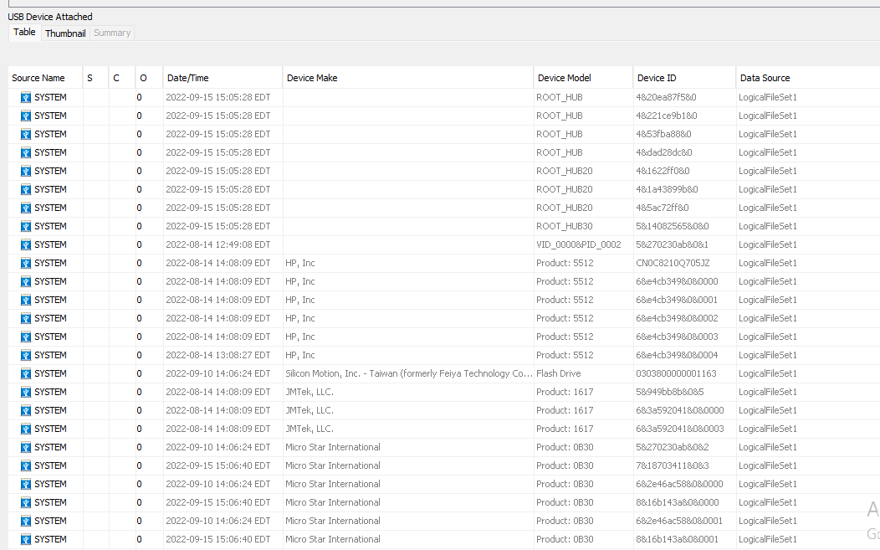

*Figure:* External storage devices.

1. Can you recover the user tile for the main user?

By navigating to DataSources, select LogicalFileSet_1, then navigate to Host and choose LogicalFileSet1->G->Windows->System32->config->SAM.

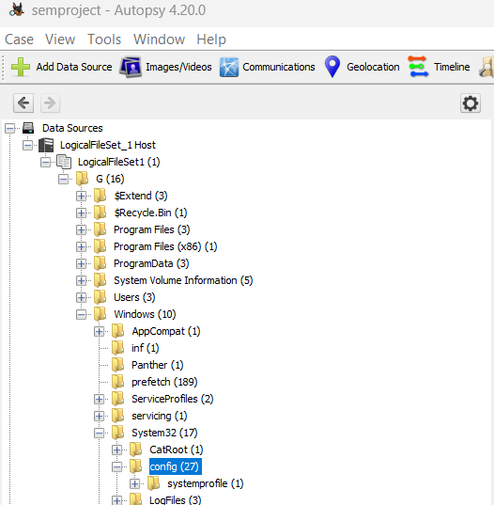

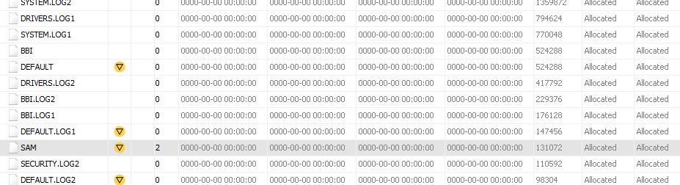

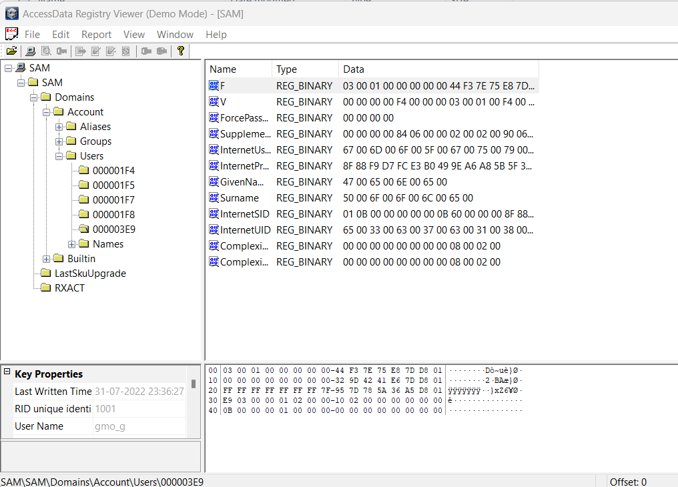

*Figure:* SAM opened in AccessData Registry Viewer

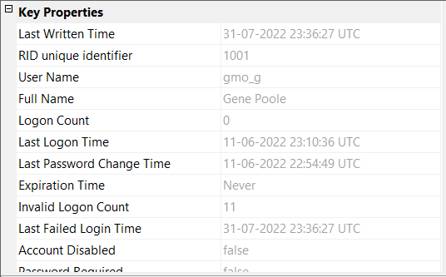

*Figure:* Properties

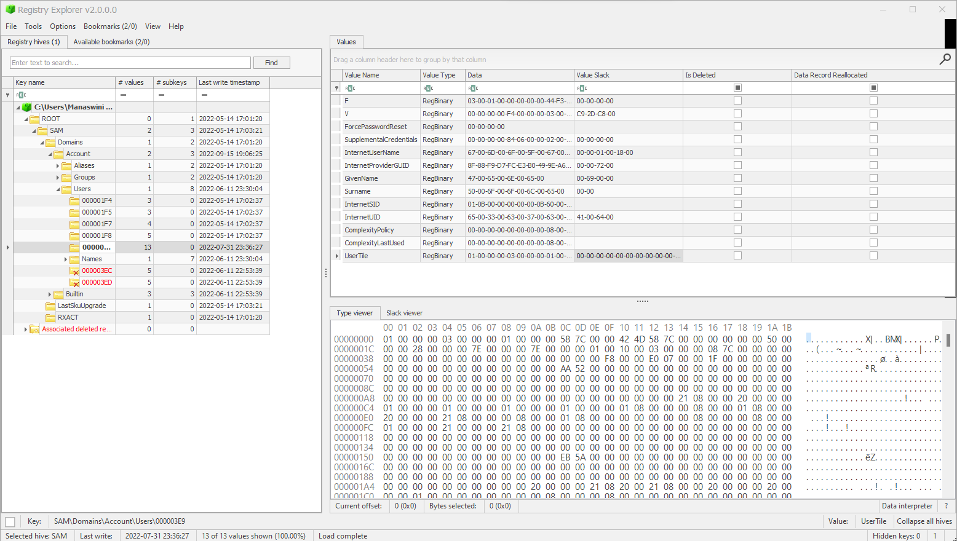

*Figure:* Registry Explorer contains value data of usertile

* By copying the value data of Usertile and converting it in hexedit we get the Image of “Panther”.

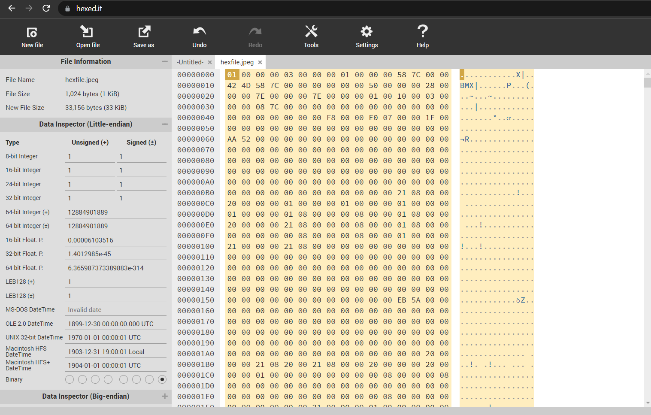



*Figure*: Image of Usertile

**Conclusion:**

I have successfully completed the lab assignment of forensically analysing Gene Poole's newest desktop. This task was particularly significant as it was Detective Jessica Fletcher's final case. The examination involved analysing a KAPE extraction and considering the possibility of anti-forensics techniques employed by Poole and his associates. Through the use of a North Carolina District Court Search Warrant and an EnCase E01 format forensic image, I was able to uncover vital information related to Poole's criminal activities. The completion of this assignment has enhanced my knowledge of forensic analysis and reinforced the importance of digital evidence in criminal investigations.